NAME: MUHAMMAD ABUBAKAR
CLASS: JSS 3A
NO: 5
ASSIGNMENT: STAR TOPOLOGY
SCHOOL: RUBY SPRINGFIRLD COLLEGE

TEACHER’S NAME: MR ADAMS

PC2

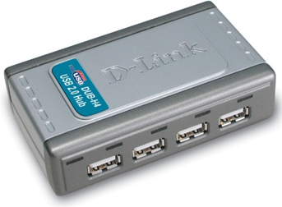
PC3
PC1

SAVER

PC5 PC4

